getClass()

1. We can use getClass()to get runtime class definition of an object.
2. Why?
   1. ArrayList can hold object of any type. We want to know to which class the object element belongs to.
   2. In JDBC, We use interface reference variable. We want to know the real class name implemented by 3rd party.  
      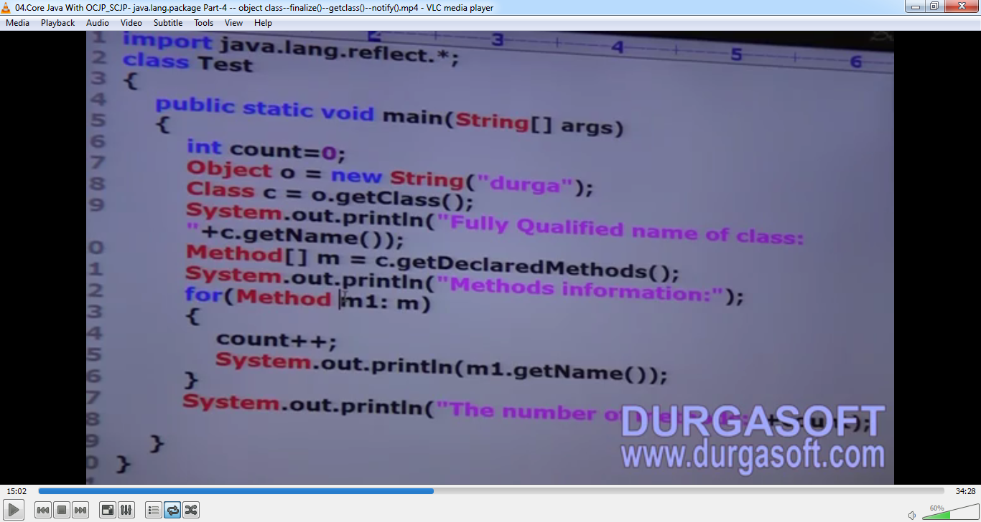
3. By using this Class class object, we can access **class level** properties. such as fully qualified name of the class, method information, constructor information etc.
4. After loading every .class file, JVM will create an object of the type java.lang.Class in the heap area. Programmer can use this class object to get class level info.  
   We can use getClass() very frequently in reflection API.

finalize()

1. Just before destroying an object, GC calls finalize() method to perform clean-up activities.
2. Once finalize() method completes, automatically GC destroys that object.

wait(), notify(), notifyAll()

1. We can use these methods for inter-thread communication.
2. The thread which is expecting updation, it’s responsible to call **wait()** then immediately enters into **waiting state**.  
   The thread which is responsible to perform updation, after performing updation, the thread can call **notify()** method.  
   The **waiting thread** will get the notification and continues its execution with those updates.